CST-361 Design Patterns in Java
Fredrick Onduso Ondieki
Activity 7B: Integration Layer Patterns
February 4, 2019

Assignment Write up:
Aspect Oriented Programming (AOP)
In Java, AOP is a third-party framework that was initially described and listed in the GOF book. AOP introduces a new concept and paradigm to programming. The whole idea of this framework is to relies on having a baseline for the code execution in order of aspects and each aspect intercepts the programs’ execution and adds its own behavior before continuing with the call.
In other words, AOP relies on code injection during compile time or run time to add all the desired features or behavior functionality to each point of an existing code base that matches the given injection criteria. In addition, frameworks that perform compile-time injection usually out-perform but they produce class files that do not match the source code line by line because of the injected code.
Aspects in Java EE, Interceptors
Interceptors are used in conjunction with Java EE managed classes to allow developers to invoke interceptor methods on an associated target class, in conjunction with method invocations or lifecycle events. Common uses of interceptors are logging, auditing, and profiling. Most importantly, interceptors in Java EE work in a similar way to aspects. Each interceptor addresses the concern and hosts the code block that contains the functionality to be added.
Interceptors can be defined in Java as a method interceptor or a class interceptor. The preferred way to define in Java code is by using meta-data annotations. They can be defined in the application descriptor as well, but in that case, they are not portable across Java EE servers. Some of the meta-data annotations found in the javax.interceptor package are: @AroundInvoke, @AroundTimeout, @PostConstruct, and @PreDestroy.
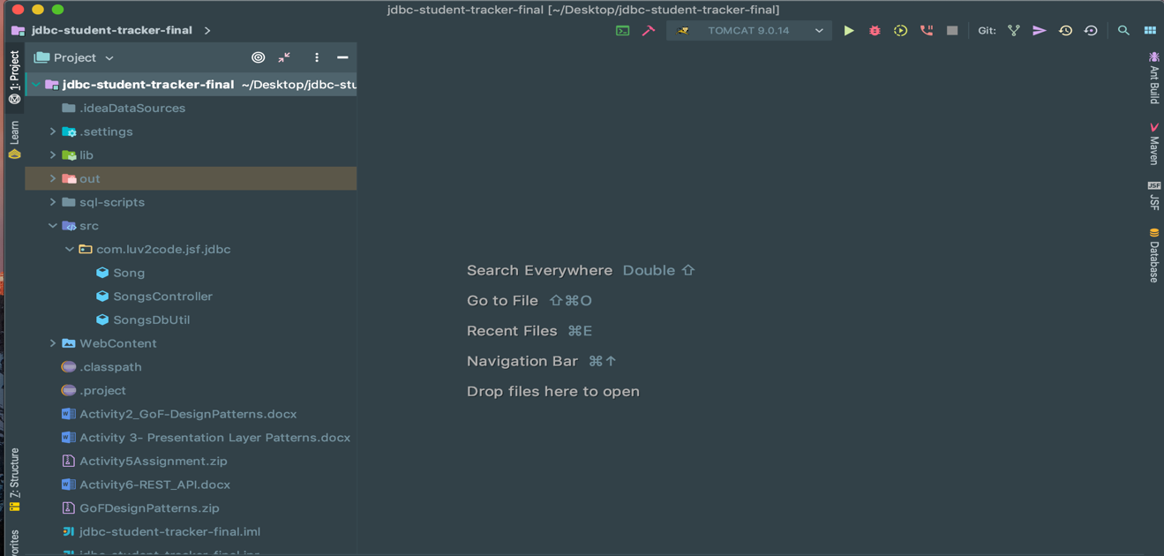
Deliverables:
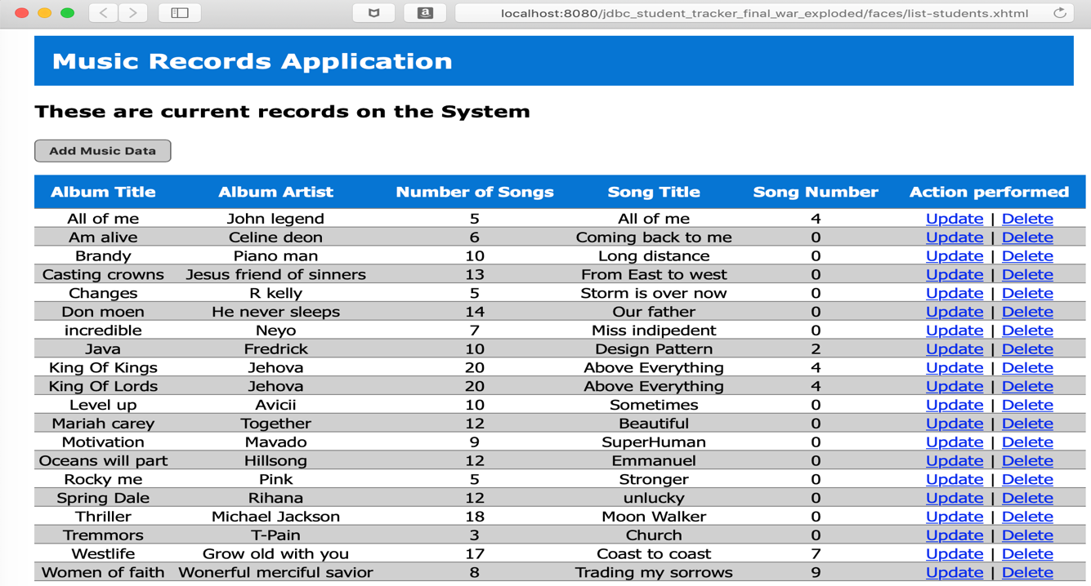
Project Structure from the IDE
Landing/Home page After program execution

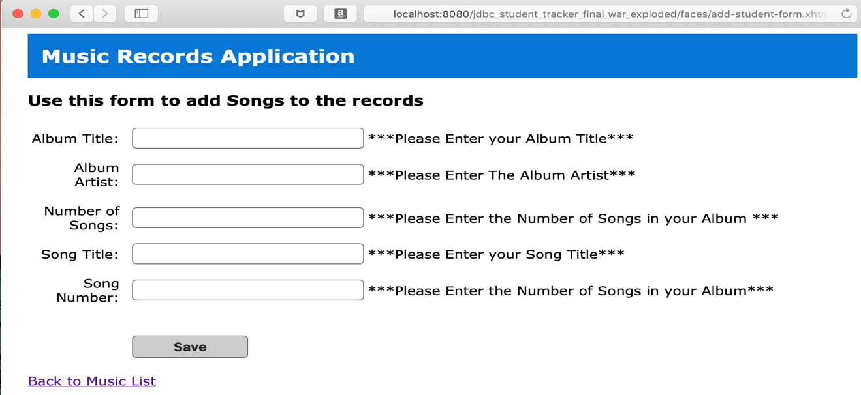
Songs Addition Entry Page

Security Validation not no enter null data to the Db
Update form to update song data
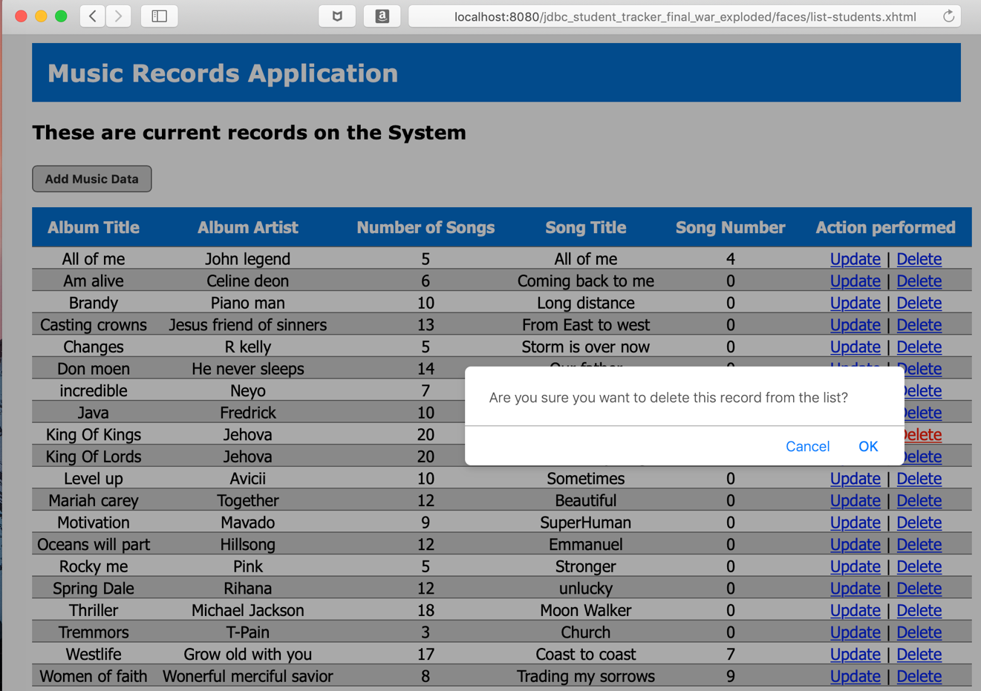
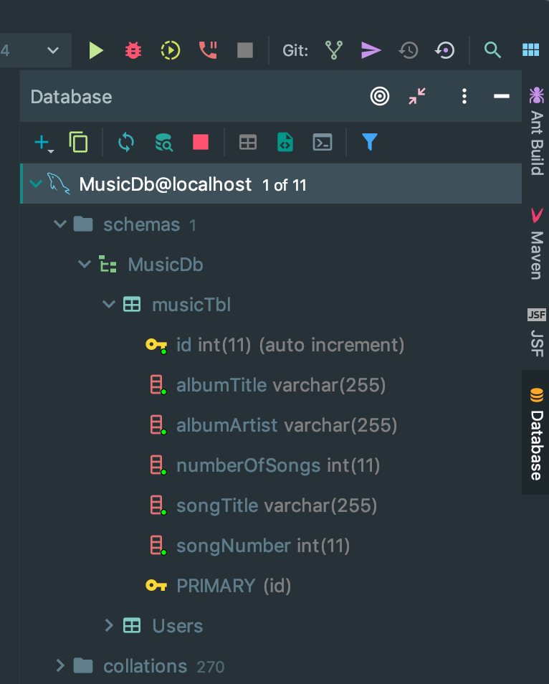
JavaScript security on the delete action
Database connection pool to MySQL relational Db
References
Debnath, M. (2014, December 22). Understanding Interceptors for Java EE. Retrieved February 5, 2019, from https://www.developer.com/java/understanding-interceptors-for-java-ee.html
AOP: The Interceptor pattern. (n.d.). Retrieved February 5, 2019, from https://www.lynda.com/Java-EE-tutorials/AOP-Interceptor-pattern/648935/732520-4.html
Chapter 9. Interceptors. (n.d.). Retrieved February 5, 2019, from https://docs.jboss.org/weld/reference/1.0.0/en-US/html/interceptors.html
Ciampa, M. (07/2011). Security+ Guide to Network Security Fundamentals, 4e, 4th Edition. [VitalSource Bookshelf Online]. Retrieved from https://everest.vitalsource.com/#/books/9781435464032/.

